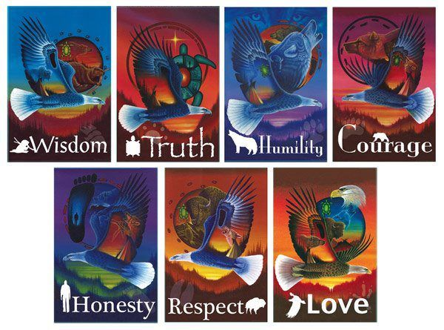 **7 GRANDFATHER TEACHINGS TASK**

**Focus:** LINE, COLOUR, FONT, EXPRESSION

**Project:** Grandfather Teaching Poster

Choose one of the teachings to focus, thinking about meaning, cultural signficance, and importance in Aboriginal Culture.

Create a poster, considering LINE, FONT TYPE and the message you want to express with this word and teaching.

Also think about the colours you want to use, and how to emphasize the lettering and the animal connected to this Teaching.